Name: Umair Ahmad Roll no: Su92-bsaim-F25-109
Class: BSAI-3B subject: Artifical intelligence (lab)
Instructor: Sir Rasikh Ali

Problem Statement:
The task is to find a low-cost route from campus building S (start) to building G (goal). A* uses f(n) = g(n) + h(n), where g(n) is the cost from the start to node n and h(n) is the estimated remaining cost. Uniform-Cost Search (UCS) is tested on the same graph by setting every heuristic value to zero.
Weighted directed graph:
S → A (1), S → B (4), A → C (2), C → G (3), B → G (5).
Start = S, Goal = G.
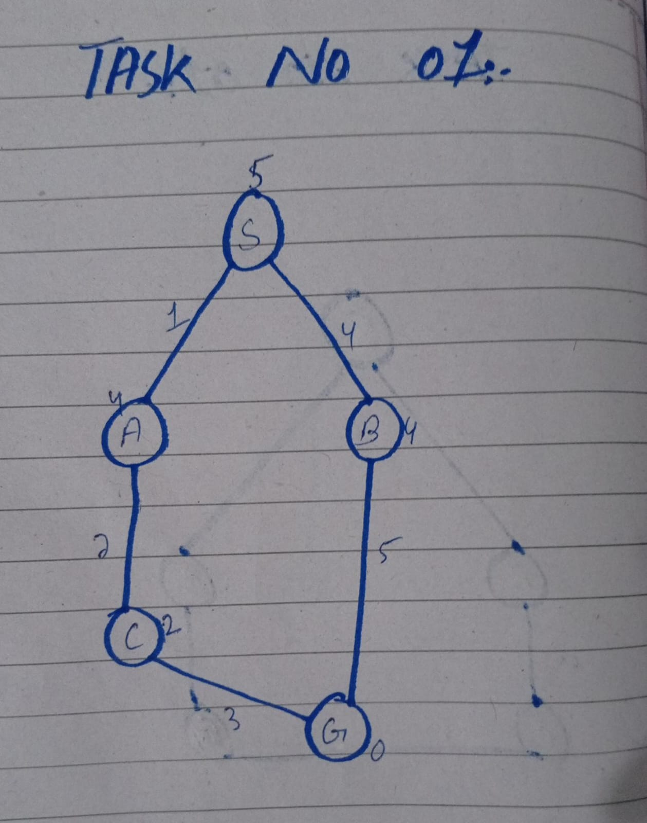
heuristic: h(S)=5, h(A)=4, h(B)=4, h(C)=2, h(G)=0.

Task 1 — Manual g, h and f Calculations:
Formula: f(n) = g(n) + h(n). The queue is ordered by lower f then lower g then alphabetical node label.

Expansion 1: Select S
g(S)=0, h(S)=5, so f(S)=0+5=5.
After expanding S: A has g=0+1=1 and f=1+4=5, B has g=0+4=4 and f=4+4=8.
Frontier after S: A(g=1,h=4,f=5), B(g=4,h=4,f=8). A is selected next because f(A)=5 < f(B)=8.

Expansion 2: Select A
g(A)=1, h(A)=4, so f(A)=1+4=5.
After expanding A: C has g=1+2=3 and f=3+2=5.
Frontier after A: C(g=3,h=2,f=5), B(g=4,h=4,f=8). C is selected next because its f-value is lower.

Expansion 3: Select C
g(C)=3, h(C)=2, so f(C)=3+2=5.
After expanding C: G has g=3+3=6 and f=6+0=6.
Frontier after C: G(g=6,h=0,f=6), B(g=4,h=4,f=8). G is selected next because f(G)=6 < f(B)=8.
The resulting path is S → A → C → G and its cost is 1+2+3=6.

Task 2 — A* and UCS Comparison:
Counting convention: a node is expanded when its successors are examined. The goal is logged as processed but is not counted as expande. Stale queue entries are ignored. Both runs use the same graph, start, goal, priority-queue implementation and tie-breaking rule.Interprettion: On this small graph, A* expands 3 nodes while UCS expands 4. This is evidence that the supplied heuristic reduces expansions for instance it is not proof that A* always expands fewer nodes on every graph.

Task 3 — Overestimate Experiment:
Only one heuristic value is changed: h(C) changes from 2 to 10. All graph edges, weights, start, goal and other heuristic values remain unchanged.Node C's true remaining cost is 3, but the modified h(C)=10. Since 10 > 3, this heuristi overstimates the remaining cost and is not admissible.
Observed trace: S → A → B → G. After A, C has g=3 and f=3+10=13, while B has f=4+4=8. B is therefore selected first and discovers G with cost 4+5=9 and f=9. G is selected before C, so the returned path is S→B→G with cost 9. The expansion count is 3 (S, A, B).
Conclusion: The returned answer changes from the optimal cost 6 to cost 9. An overestimating heuristic can cause A* to select a more expensive goal path before exploring the cheapr route. Once admissibility is violated the optimality guarantee no longer applies even if a different overestimate happens not to change a particular run.

Edge Case / Failure Analysis:
Input: same graph, but h(C)=10 instead of 2.Observed behavior: A* returns S→B→G with cost 9 instead of the least-cost path of cost 6.Likely cause: the inflated heuristic makes f(C)=13, so C is delayed behind B and the goal reached through B.Proposed improvement: use a heuristic in the same units as edge costs and verify admissibility/consistency against known true costs on test graphs before relying on optimality.Additional edge case: a node may be reached later through a more expensive path. The implementation keeps best-known g-values and ignores stale queue entries.

Reflection:
What did I learn?
I learned how g, h and f determine A*'s priority and how to compare A* with UCS using measured expansion counts.
How can I apply this?
A* can help find low-cost routes in campus navigation, maps and other pathfinding systems.
What surprised me?
Changing only h(C) to an overestimate changed the result from cost 6 to cost 9.
What would I do differently? I would test heuristics on multiple graphs, verify their units, and record traces and counts consistently.

Responsible Practice and Limitations:
The edge costs are abstract travel-time units from the lab manual, not measured campus distances. Heuristic values must use the same units as edge costs. The comparison is based on this small supplied graph only. The code and outputs are included for reproducibility, any borrowed code or factual sources should be cited. No credentials, private information or virtual environments should be uploaded.

